Name:______________________________
The Silver Age

Here is Ovid’s description of the Silver Age:
When Saturn was banished to gloomy Tartarus, and Jupiter ruled the world, then came the people of the age of silver that is inferior to gold, more valuable than yellow bronze. Jupiter shortened spring’s first duration and made the year consist of four seasons, winter, summer, changeable autumn, and brief spring. Then parched air first glowed white scorched with the heat, and ice hung down frozen by the wind. Then houses were first made for shelter: before that homes had been made in caves, and dense thickets, or under branches fastened with bark. Then seeds of corn were first buried in the long furrows, and bullocks groaned, burdened under the yoke.

Compare Ovid’s description to the woodcut by Vergilius Solis (1514-1562) depicted below. What details in Vergilius’ drawing are based directly on Ovid’s poem? What details does Vergilius leave out? Why?
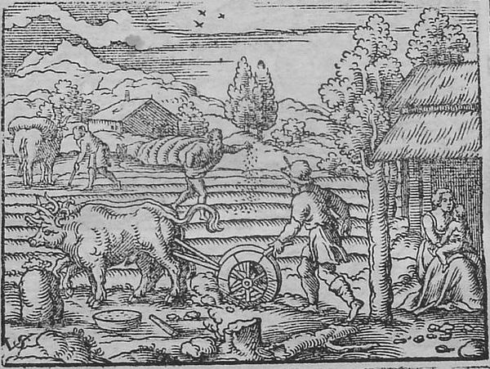
Begin your answser here and continue onto the back, if necessary:

