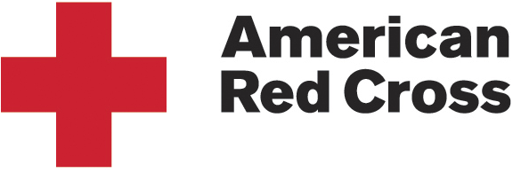  Heart of America Region |  | 405 W. John H. Gwynn Jr. Avenue  Peoria, IL 61605  Tel (309) 636-4235  Fax (309) 636-4477  www.redcross.org
July 30, 2026

Hello Community Partner:

When you're committed to providing relief and hope to millions of people around the world every day, you need the support of others who share that dedication and who want to contribute to it. That's why the American Red Cross has always been there for others, because you are there for us.

As one of the nation's leading nonprofit organizations, we attract talented, motivated and enthusiastic people who make our mission to save lives a reality and who experience the greatness of the human spirit at its best.

The Heart of America Blood Services Region is currently seeking female/minority candidates to apply for the position of Collections Technician II, Mobile Unit Assistant II, Donor Recruitment Representative, Collections Specialist Team Supervisor, and Program Marketing Manager. While we are seeking female/minority candidates for these positions, we will consider all qualified candidates. If you know a candidate that may help us fill these positions, I would appreciate it if you put them in touch with me. My contact information is below.

Our humanitarian mission connects us to people and communities across the nation and around the world. We are committed to the diversity of our people, programs and services, and we are proud to be an equal opportunity employer. The organization acts affirmatively in the employment and advancement of qualified women, minority group members, disabled veterans, Vietnam-era veterans, other covered veterans and those individuals who are physically and/or mentally disabled and otherwise qualified.

Kind Regards,

Holly Nelson
Heart Of America Blood Services Region
405 W. John H. Gwynn Jr. Avenue Peoria, IL 61605
309-636-4235

