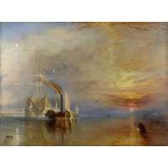
Samuel Wordsworth
Victorian Culture
Painting Presentation
September 24, 2004

J.M.W. Turner's The Fighting “Téméraire,” Tugged to Her Last Berth to be Broken Up. (1838)

Biography

Composition

My Reactions

Critics Reactions

Overview

Bibliography

