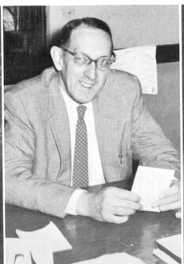
Garvin Davenport 1959 Ravelings

