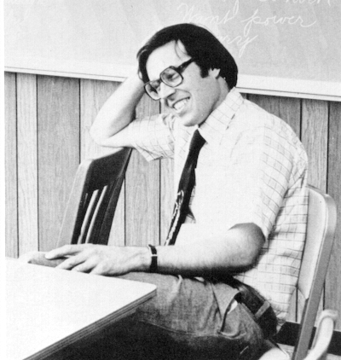
George Arnold. Ravelings 1978.

ñ Back to History Home Page

