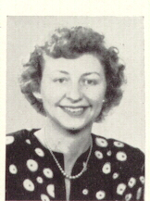
Mary Bartling (Crow) Ravelings 1948 Mary Crow in 1959 Ravelings
