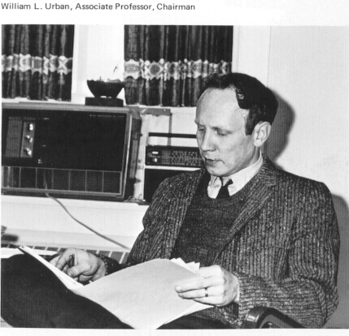
William Urban 1973 Ravelings
In the new history offices in Carnegie, the first time the department had an office area of its own. Urban, Spitz, Crow, and Brett were in the basement together, with two professors of government and the visiting Japanese language instructor. Davenport and Tselos were over in Woodbine.

