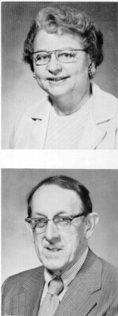Mary Crow and  Garvin Davenport 1973 Ravelings | Douglas Spitz and George Tselos  